Run Python scripts in Power BI Desktop
Prerequisites
Work through Run Python scripts in Power BI Desktop to:
- Install Python on your local machine.
Install Python - https://www.python.org/downloads/
- Enable Python scripting in Power BI Desktop. - In Power BI Desktop, select File > Options and settings > Options > Python scripting.
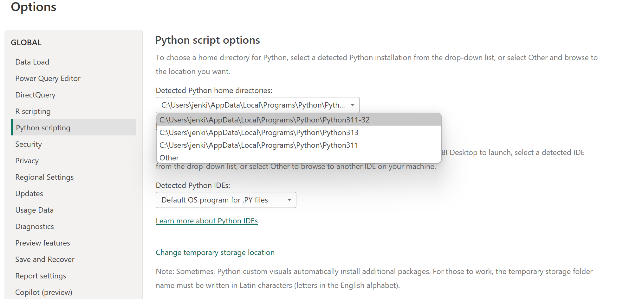
- Install the pandas and Matplotlib Python libraries.
Install matplotlib, Pandas , Seaborn
pip install pandas
pip install matplotlib
pip install Seaborn

Step 1: Import Dataframe
- Go to -> Get Data
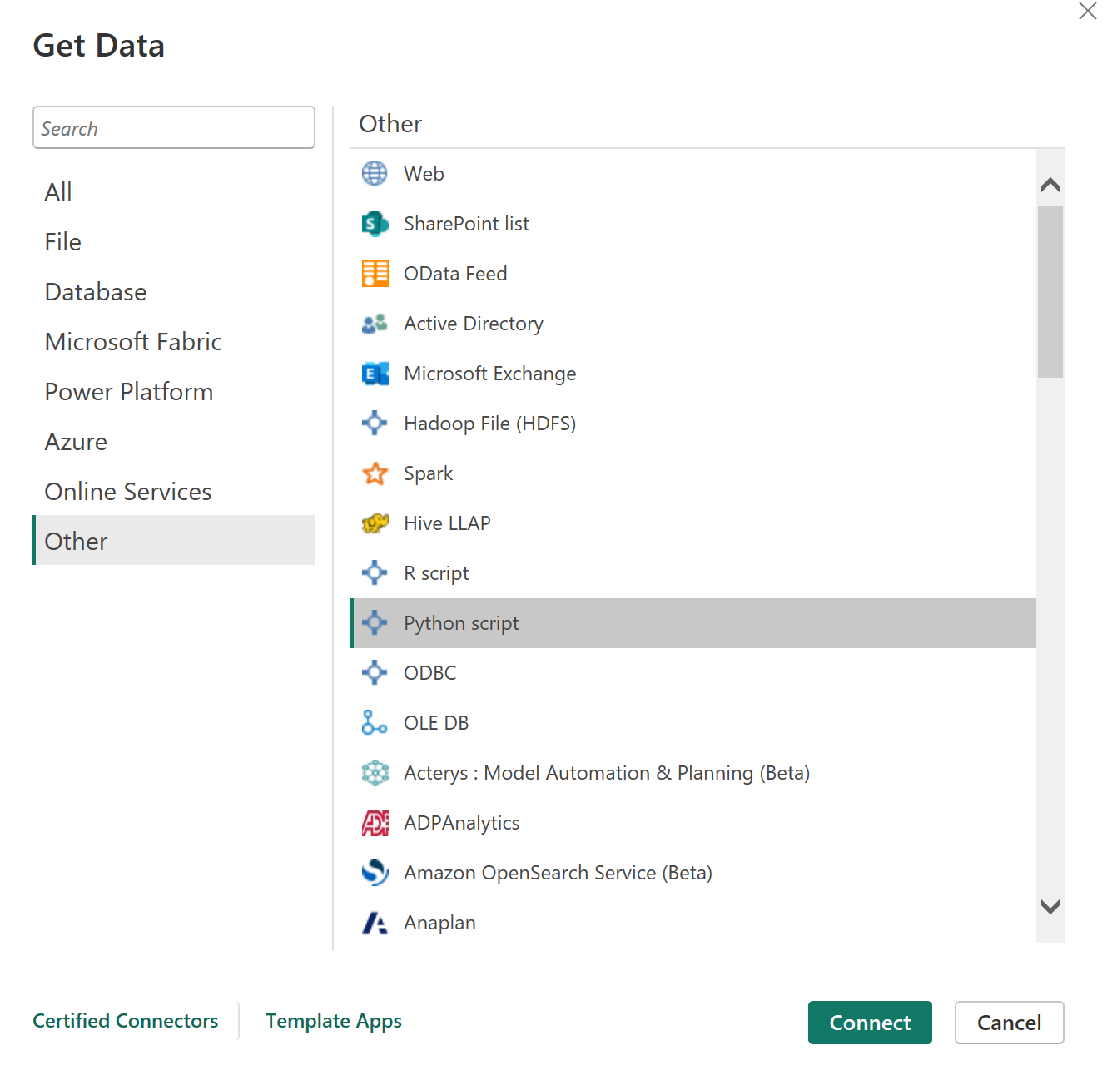
Click Connect
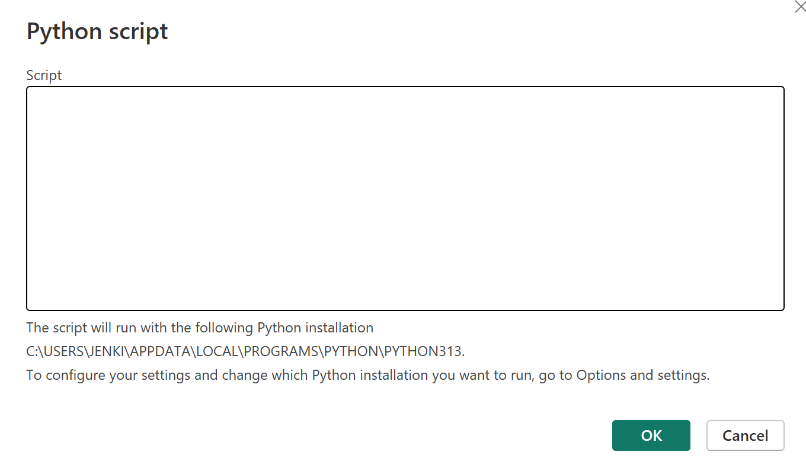
Enter below code to create DataFrame

import pandas as pd
df = pd.DataFrame({
'Fname':['Harry','Sally','Paul','Abe','June','Mike','Tom'],
'Age':[21,34,42,18,24,80,22],
'Weight': [180, 130, 200, 140, 176, 142, 210],
'Gender':['M','F','M','M','F','M','M'],
'State':['Washington','Oregon','California','Washington','Nevada','Texas','Nevada'],
'Children':[4,1,2,3,0,2,0],
'Pets':[3,2,2,5,0,1,5]
})
print (df)

It will create a data source
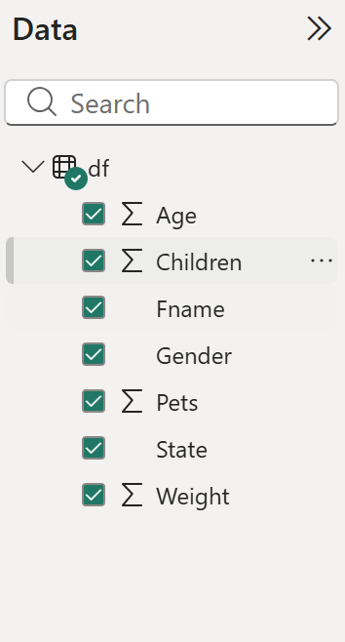

Create a Python visual in Power BI Desktop
After you complete the prerequisites, you have a table in Power BI Desktop that contains the sample data from the Python script: Fname, Age, Weight, Gender, State, Children, and Pets. This tutorial uses that table to create visuals.
- Select the Python visual icon in the Power BI Desktop Visualizations pane.
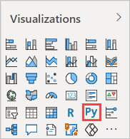
- In the Enable script visuals dialog box that appears, select Enable.
A placeholder Python visual image appears on the report canvas, and the Python script editor appears along the bottom of the center pane.
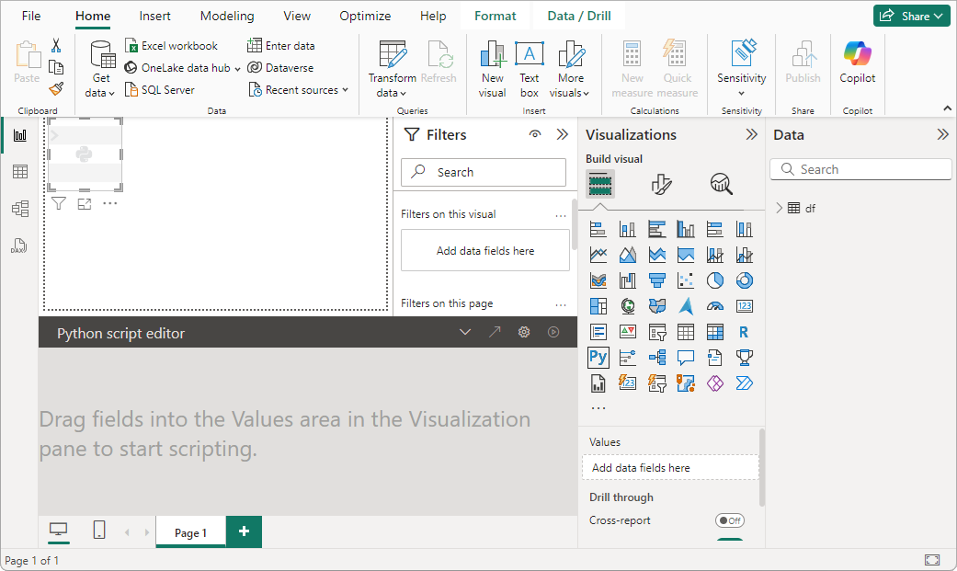
- Drag the Age, Children, Fname, Gender, Pets, State, and Weight fields to the Values section where it says Add data fields here.
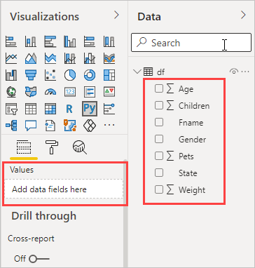

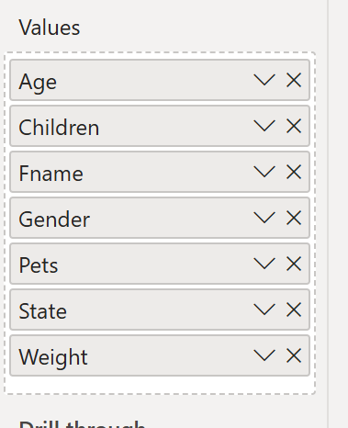
Create a scatter plot
Create a scatter plot to see if there's a correlation between age and weight.
- In the Python script editor, under Paste or type your script code here, enter this code:
Python
import matplotlib.pyplot as plt
dataset.plot(kind='scatter', x='Age', y='Weight', color='red')
plt.show()
Your Python script editor pane should now look like the following image:
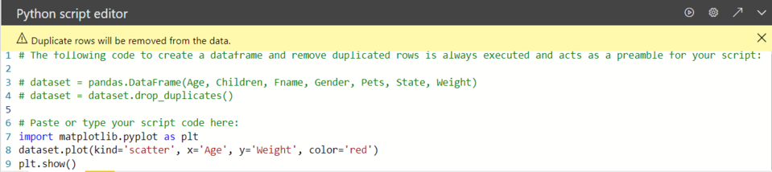
The code imports the Matplotlib library, which plots and creates the visual.
- Select Run to generate the following scatter plot in the Python visual.
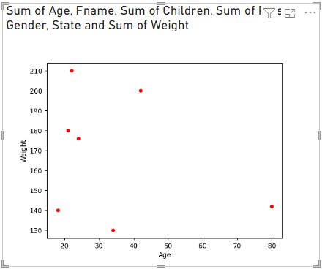

Create a line plot with multiple columns
Create a line plot for each person that shows their number of children and pets.
- Under Paste or type your script code here, remove or comment out the previous code, and enter the following Python code:
Python
import matplotlib.pyplot as plt
ax = plt.gca()
dataset.plot(kind='line',x='Fname',y='Children',ax=ax)
dataset.plot(kind='line',x='Fname',y='Pets', color='red', ax=ax)
plt.show()
- Select Run to generate the following line plot with multiple columns:
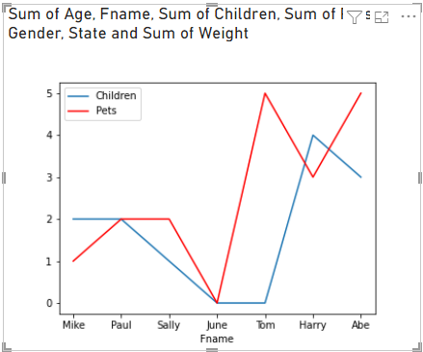

Create a bar plot
Create a bar plot for each person's age.
- Under Paste or type your script code here, remove or comment out the previous code, and enter the following Python code:
Python
import matplotlib.pyplot as plt
dataset.plot(kind='bar',x='Fname',y='Age')
plt.show()
- Select Run to generate the following bar plot:
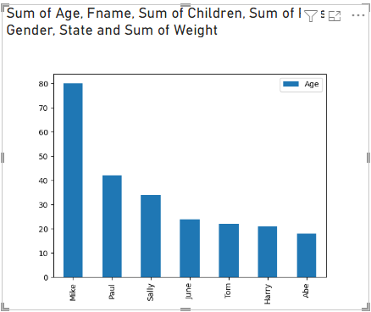

Final Output
